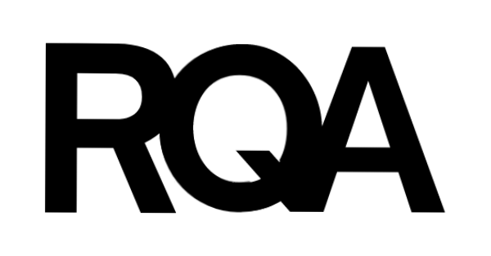

Please write clearly in block capitals.

**Paper 1 Non-Calculator**

**Foundation Tier**

GCSE

**MATHEMATICS**

I declare this is my own work.

Candidate signature

Forename(s)

Surname

Candidate Number

Centre Number

Morning

Time allowed: 1 hour 30 minutes

|  |  |
| --- | --- |
| For Examiner’s use | |
| Pages | Mark |
| 2-3 |
| 4-5 |
| 6-7 |  |
| 8-9 |  |
| 10-11 |  |
| **TOTAL** |  |

Day X June 2024

**8300/1F**

2

*Do not write outside the box*



0 2

**3**

Circle the percentage that is between ½ and 3/4

40% 60% 80% 90%

**[1 mark]**

**2**

A circle has diameter 10 cm

Circle the radius.

5 cm 10 cm 20 cm 100 cm

**[1 mark]**

**1**

Circle the length of time between 4.00pm and 5.05pm

55 min 65 min 105 min 125 min

**[1 mark]**

Answer **all** questions in the spaces provided.

3

*Do not write outside the box*



**4**

Circle the value of 3² + 4²

14 17 25 49

**[1 mark]**

**5**

Simplify fully *8a + 5b + 6a – 2b*

**[2 marks]**

Answer

**Turn over for the next question**

0 3

4

*Do not write outside the box*

|  |  |  |
| --- | --- | --- |
|  | **Less than £25** | **£25 or over** |
| **School Students** | 40 | 90 |
| **College Students** | 32 | 38 |



**6**

200 students were each asked about the monthly cost of their phone contract. Here are the results.

**6 (b)**

What percentage of the 200 students had a monthly cost **less than £25?**

**[2 marks]**

Answer

**6 (a)**

How many **more** school students than college students were asked?

**[2 marks]**

Answer

0 4

5

*Do not write outside the box*



**8**

Some gamers were asked which type of video game they preferred.

65% said Action.

19% said Role-playing.

The reset said Sports.

What percentage said Sports?

**[2 marks]**

Answer

%

**7**

The only animals on a farm are 30 cows and 80 sheep.

1/5 of the 30 cows are sold

And

5/8 of the 80 sheep are sold.

Work out the **total** number of animals that are sold.

**[3 marks]**

Answer

0 5

6

**DO NOT WRITE ON THIS PAGE**

**ANSWER IN THE SPACES PROVIDED**

**There are no questions printed on this page**

*Do not write outside the box*



0 6

7

*Do not write outside the box*



**9 (a)**

A diagonal of a rectangle is drawn on a centimetre grid.

The sides of the rectangle are on the grid lines.

**[2 marks]**

Answer

Work out the area of the rectangle.

cm²

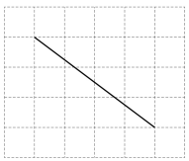

**9 (b)**

One side of a parallelogram is drawn on this centimetre grid. The parallelogram does not have any right angles.

Complete the parallelogram so that it has area 24 cm²

**[2 marks]**

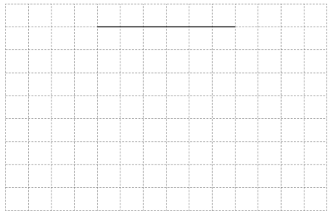

0 7

8

*Do not write outside the box*

**10 (b)**

Circle the answer to 214 x 30

**[1 mark]**

1284 3210 6420 25 680

**10 (a)**

Write down the answer to 12840 ÷ 428

**[1 mark]**

Answer

**10**

Here is a calculation.

428 x 30 = 12840

Use the calculation to help answer the following questions.

**9 (c)**

Two sides of a rhombus are drawn on this grid.

Complete the rhombus.

**[1 mark]**

0 8

9

*Do not write outside the box*



**11 (b)**

Work out the cheapest cost of 10 pencils.

**[3 marks]**

Answer £

**11 (a)**

Marek buys some **packs** of notebooks.

The cost is £60

In total, how many **notebooks** did he buy?

**[2 marks]**

Answer

**Pencils**

56p each

Or

Pack of 6 for £2.70

**Notebooks**

Pack of 8 for £12

**11**

A shop sells notebooks and pencils.

0 9

10

*Do not write outside the box*

**END OF QUESTIONS**

**11 (c)**

The shop also sells folders for £3.20 each.

The shop has this offer.

Work out the cost of 4 folders using the offer.

**[3 marks]**

Answer £

1 0

11

**DO NOT WRITE ON THIS PAGE**

**ANSWER IN THE SPACES PROVIDED**

**There are no questions printed on this page**

*Do not write outside the box*



1 1

IB/M/JUNE24/8300/1F

**Copyright information**

For confidentiality purposes, all acknowledgements of third-party copyright material are published in a separate booklet. This booklet is published after each live examination series and is available for free download from www.rqa.co uk.

Permission to reproduce all copyright material has been applied for. In some cases, efforts to contact copyright-holders may have been unsuccessful and AQA will be happy to rectify any omissions of acknowledgements. If you have any queries, please contact the Copyright Team.

Copyright © 2022 AQA and its licensors. All rights reserved.